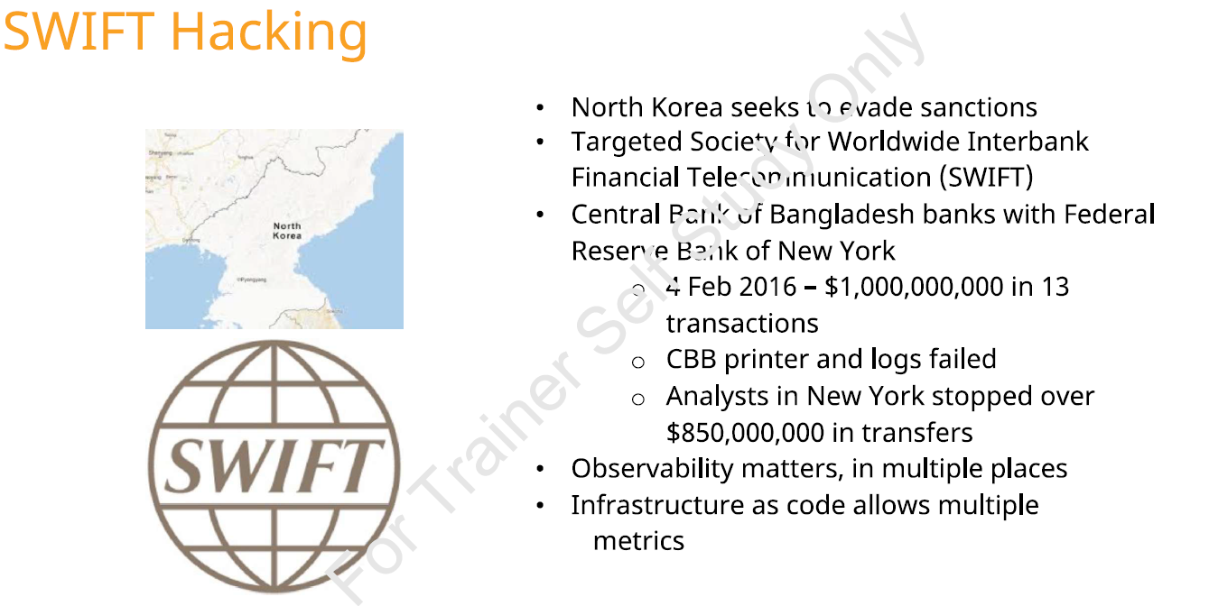

This slide describes the 2016 Bangladesh Bank SWIFT cyberattack, one of the most significant financial cyber incidents in history.

What the Picture Shows
Context: North Korea & Sanctions Evasion
- The slide mentions North Korea seeking to evade sanctions.
- The attack has been widely attributed to the Lazarus Group, linked to North Korea.
The motive:
Steal foreign currency through cyber operations to bypass economic sanctions.

Target: SWIFT Network
SWIFT = Society for Worldwide Interbank Financial Telecommunication
- Global messaging network used by banks to transfer money securely.
- Does NOT hold money itself.
- Sends authenticated transaction instructions between banks.
In this case:
- Attackers compromised the Central Bank of Bangladesh (CBB).
- Fraudulent SWIFT messages were sent to the Federal Reserve Bank of New York.

The Attack (Feb 4, 2016)
- Attempted to transfer $1 billion in 13 transactions.
- $850 million was stopped by Fed analysts.
- About $81 million was successfully stolen.
Critical failure points mentioned:
- 🖨 CBB printer failed
  - SWIFT confirmation printouts did not print due to malware.
  - No one saw the fraudulent transactions immediately.
- 📄 Logs were compromised
  - Malware manipulated logs to hide activity.
  - Monitoring systems were ineffective.
Key Lesson on the Slide
"Observability matters, in multiple places"
This is the core DevSecOps message.

Relevance to DevSecOps
This attack is a textbook example of why DevSecOps + Observability is critical.

Security Must Be Embedded, Not Bolted On
Traditional setup:
- SWIFT system isolated
- Perimeter security focused
- Minimal runtime visibility
DevSecOps principle:
- Security integrated in development, deployment, and operations.
- Continuous validation.

Observability Failures Led to the Breach
Major issues:
No real-time anomaly detection
- Large international transfers should have triggered alerts.
Log tampering not detected
- Logs were altered by malware.
- No centralized immutable logging.
Single-point monitoring failure (printer)
- Monitoring relied on a physical printer output.
- No redundant alerting mechanism.

DevSecOps Solution:
Centralized log aggregation (SIEM)
Immutable logging
Real-time anomaly detection
Multi-channel alerting
Behavioral analytics

Infrastructure as Code (IaC) & Policy Enforcement
“Infrastructure as code allows multiple metrics”
In DevSecOps:
- Infrastructure is declarative.
- Security policies are codified.
- Monitoring agents are deployed automatically.
- Configurations are version-controlled.
If implemented properly:
- Logging cannot be disabled silently.
- Monitoring services auto-scale.
- Compliance is continuously validated.

Shift-Right Security (Runtime Security)
DevSecOps is not just CI/CD scanning.
Runtime security includes:
- Transaction anomaly detection
- Privilege escalation monitoring
- File integrity monitoring
- Network traffic inspection
In the SWIFT case:
- Malware sat undetected.
- Lateral movement occurred.
- Outbound fraud went unnoticed initially.
Modern DevSecOps would use:
- EDR (Endpoint Detection & Response)
- SIEM with real-time correlation
- Zero-trust network access
- Continuous threat intelligence feeds

Importance of Defense in Depth
The attack succeeded because:
- Endpoint security failed.
- Logging failed.
- Human process failed.
- Monitoring failed.
DevSecOps promotes:
Multiple layers of:
- Prevention
- Detection
- Response
- Recovery

Automated Guardrails & Policy-as-Code
Imagine this in a DevSecOps model:
- Any transfer > $10M triggers:
  - Automatic hold
  - Multi-person approval
  - Security review
  - Behavioral anomaly check
These controls can be enforced using:
- Policy-as-Code (OPA, Sentinel)
- Workflow automation
- Risk-based alerting

Core DevSecOps Takeaway from This Slide
The SWIFT attack proves:
If observability is weak, attackers win quietly.
DevSecOps ensures:
- Continuous monitoring
- Automated detection
- Rapid response
- Infrastructure transparency
- Security embedded in pipelines

How This Connects to Your DevSecOps Module
This case is perfect for teaching:
- Importance of observability
- Runtime security monitoring
- Log integrity and tamper detection
- Multi-layer alerting systems
- Financial system security architecture
- Why “security by isolation” fails

Summary
The SWIFT hacking case demonstrates that without continuous observability, runtime security, and automated controls, even high-security financial systems can be compromised — making DevSecOps essential for modern critical infrastructure.

